BANGKOK 4 DAYS 3 NIGHTS
Private
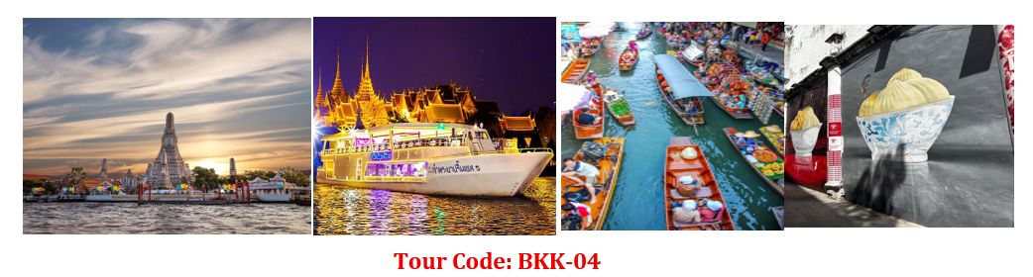

Tour Highlights • Wat Arun (Temple of Dawn)• Sunset by Chao Phraya Princess Cruise
• Damnoen Saduak Floating Market
🌴 Complimentary Drink: Young Coconut or Thai Tea
DAY 01 — Arrival in Bangkok (NO meal)
• Assemble at airport for flight to Bangkok
• Visit Songwat Road Street ART
• Explore Sampheng Wholesale Market
• Enjoy Bantadthong Night Street Food
DAY 02 — Bangkok (Breakfast / Lunch / Own Dinner)
• Visit Damnoen Saduak Floating Market (boat ride included)
→ Experience local merchants selling goods from traditional boats
• Mae Klong Railway Market – The market that operates right on train tracks!
• Shopping at Platinum Fashion Mall and Big C Supermarket
• Lunch included / Dinner at your own arrangement
DAY 03 — Bangkok (Breakfast / Lunch / Dinner)
• Wat Arun – Boat ride along the Chao Phraya River & visit the iconic temple
• Golden Buddha Temple – Admire the 5.5-tonne solid gold statue
• Free time shopping at IconSiam Mall
• Dinner & Sunset Cruise at Asiatique Riverfront aboard the Chao Phraya Princess Cruise
DAY 04 — Departure (Breakfast)• Transfer to airport for flight home
✈️ Bringing back wonderful memories & superb souvenirs!

Validity: 01 November – Mar’2027
Tour Code: BKK-04 -
Hotel List | Package rate THAI BAHT/ per person  Twin /Triple sharing |  |  | Single  Supp + | Extension Night  Incl. Breakfast + Transfer
 | 10+1 pax | 15+1 pax | 20+1 pax |  | Single | Twin
3star | 9,700 | 8,400 | 7,700 | 2,300 | 1,700 | 1,700
- Muslim Hotel: Almas Hotel – Zayn Hotel – Lilit hotel -Regent Ramkhamhaeng or similar class
- Picnic Hotel – Twin Tower – Pannarai – Baiyoke Boutique -Prom Hotel Ratchada-Ibis Ratchada

4star | 10,800 | 9,400 | 8,800 | 3,400 | 2,600 | 2,600
Hotel list: 4-star hotel (option 1)
- Almeroz Hotel – Nouvo city -Bangkok Midtown – Mandarin by Center point - Ibis Siam or similar
- Vince Pratunam– Pure Eleven – Mercure makksan - Holiday in Sukhumvit 22 or similar class

4star | 11,400 | 9,900 | 9,400 | 4,200 | 3,000 | 3,000
Hotel list: 4-star hotel (option 2)
- Centara Watergate pavilion – The Berkeley pratunam – Mercure Siam – Avani Ratchada
- Grand Mercure Atrium - Armona Grand – CenterPoint plus Pratunam

5star | 13,500 | 12,000 | 11,500 | 6,100 | 4,900 | 4,900
Hotel list: 5-star hotel
- Amari Bangkok – Pullman king power – Moxy Ratchaprasong by Marriott - Prathumwan Princess , Novotel Platinum – Novotel Siam – Centara Grand at Central world

Child Policy
• Child sharing twin bed: same rate as adult
• Child with bed: 75% of adult fare
• Child without bed: 50% of adult fare
Compulsory tipping: THB 100 / person / day
Surcharge Periods
• 25 Dec 2026 – 02 Jan 2027 (New Year): +THB 800 / room / night
• 04-08 February Chinese New Year): +THB 800 / person
Package Includes
3-night hotel accommodation with breakfast (Bangkok)
Transportation by BUS
All tours & entrance fees as mentioned
2 Lunches & 1 Dinners at local restaurants
English /Chinese or Bahasa speaking guide
Tourist insurance
2 bottles of drinking water per person per day
TERM AND CONDITIONAL:
- Price quote in Thai Bath (THB)
- Above tour fare is for Asian Nationality only.
- Table setting for Thai Restaurant will be set as 4pax/table/set or 6pax/table/set meal, Chinese set dinning will be set 8-10 pax/table/set.
- ALL RESTAURANTS MAY BE CHANGED WITHOUT PRIOR NOTICE.
- In case the Hotel envisages or normal categories of Rooms are wait listed / sold out, alternate hotel/category. Will be provided & we will keep you informed on the supplement / reduction involved.
- We have NOT booked any rooms at any mentioned hotels; once we received confirmation from you will check the rooms available and book rooms at all above.
- The cost is based on mentioned above paying pax travelling, any addition or reduction in the number of pax would change the cost accordingly.
- All hotel check in 14.00 p.m. and check out time is 12.00 pm.
- Prices are subjected to change without prior notice, in case of fluctuation in exchange rate or increase in fuel surcharge.

If you need any questions about this package, please CONTACT
MS.fon HP+6694-5469539 / MS AMEE HP+6692-2518492 /MS ELIN HP+6017688 6001
Email: ggm.thaitravel@gmail.com , ggm.managerthaitravel@gmail.com , ggmthaimanagement@gmail.com

Thank you for your away support us!

